Minneapolis BlowerDoor measuring systems now with the new DG-1000 pressure gauge

The DG-1000, successor to the tried and tested DG-700 pressure gauge, convinces with its intuitive use, clear structure, and modern design. Its high-resolution touch screen and intelligent micro-processor provide you with the functions of a modern mini-computer. New requirements are constantly fed into the measuring software and users can install and run the latest software updates free of charge at any time. The DG-1000 comes equipped with USB and Ethernet ports, as well as an integrated WiFi module giving you the option of controlling the BlowerDoor measurement from your laptop from any suitable location in the building.
BlowerDoor measurements recording and evaluating a measuring series according to ISO 9972 or EN 13829, are conducted with the TECTITE Express 5.1 software.
When performing quality assurance tests, you can search for leakages with the DG-1000 or the TEC Gauge App at a constant building pressure differential. The high accuracy of the DG-1000 guarantees reliable measuring results at maximum precision. The DG-1000 is compatible with all presently existing and new BlowerDoor Measuring Systems and may also be purchased as an upgrade. According to the manufacturer’s indications, the calibration interval is 2 years.

Characters: 1,325

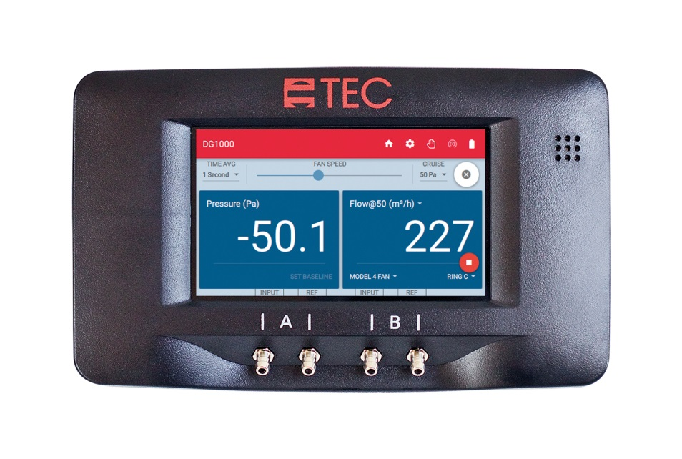

BlowerDoor GmbH
MessSysteme für Luftdichtheit
Zum Energie- und Umweltzentrum 1
31832 Springe-Eldagsen
www.blowerdoor.de

Contact: Andrea Doll
Phone +49 (0)5044 975-45
E-mail: doll@blowerdoor.de

